Quite often, we are not aware of the amount of media we consume each day. After starting this field study, I began to take more notice of the advertisements and company names display across not only the expansive campus, but even within my own room. From publisher names to health care products, the names of companies have started to define the products. While observing the many titles within my own room and on the internet, I began to notice multiple media being used within a single product.
Cartoon Voiceover Vines on YouTube
Youtube -> Vine -> Cartoons (Nickelodeon, Cartoon Network)
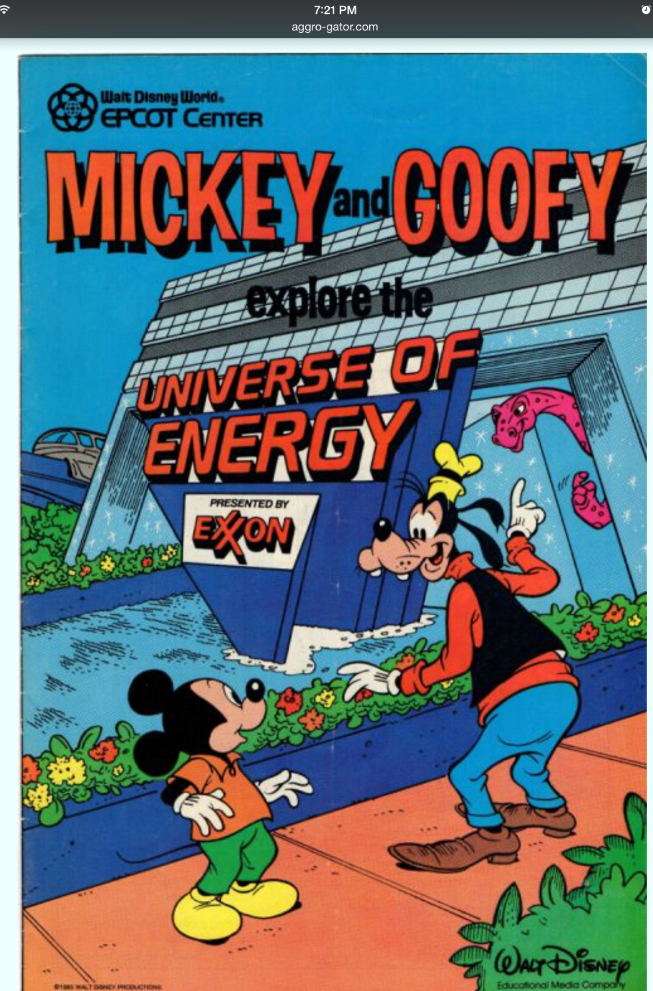
I’ve noticed that many products no longer stand alone. This YouTube video is a compilation of Vines of popular cartoon characters. Websites often have posts of products that also contain advertisements or sponsorships of other items. The next item is from a forum called agro-gator.com which had a post of an ad for the Epcot Center, which then is sponsored by Exxon.
Even meals consist of multiple brands making up parts of the dietary requirement. A restaurant’s entrée is then accompanied by “Pepsi products” and a side of Kraft products. Similarly, advertisements for competing products and complementary products subsequently expose the audience to a bit of the influence of each other.
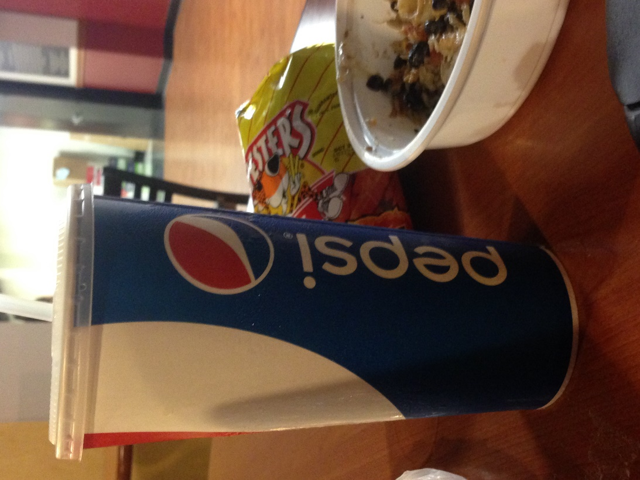
Gallo de Oro meal with large Pepsi cup and Hot Cheetos.

Ipad advertising America’s got Talent within an xfinity advertisement.

Competing companies, PepsiCo and Coca-Cola Co. are both featured in this Pepsi commercial which advertises concert promotional events.

